Game Design Document

1. Game Element

* Spaceship:

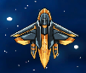

* Asteroid: spawn randomly, player lose health when get hit by asteroid

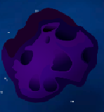 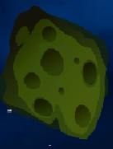

* Star: collect star to finish the level



1. Game Scenes

* Menu scene:

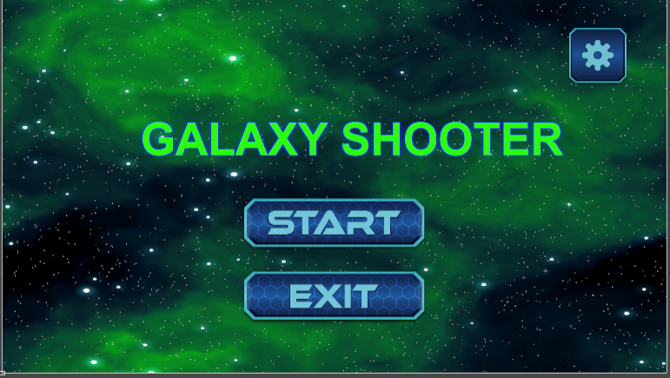

* 1st play scene:

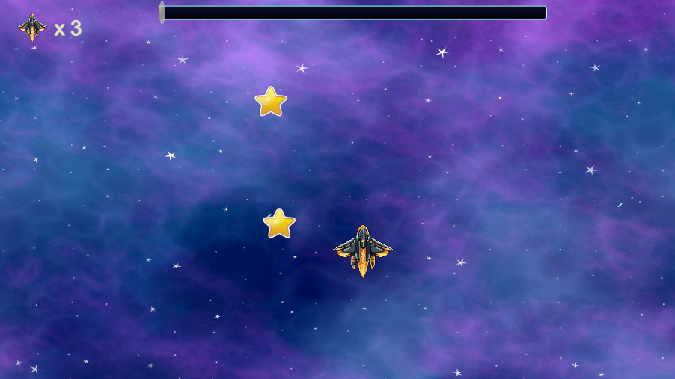

* 2nd play scene

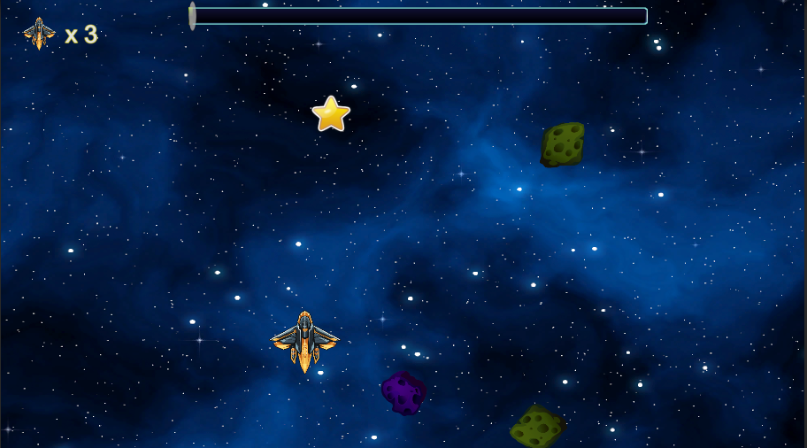

* Lose scene

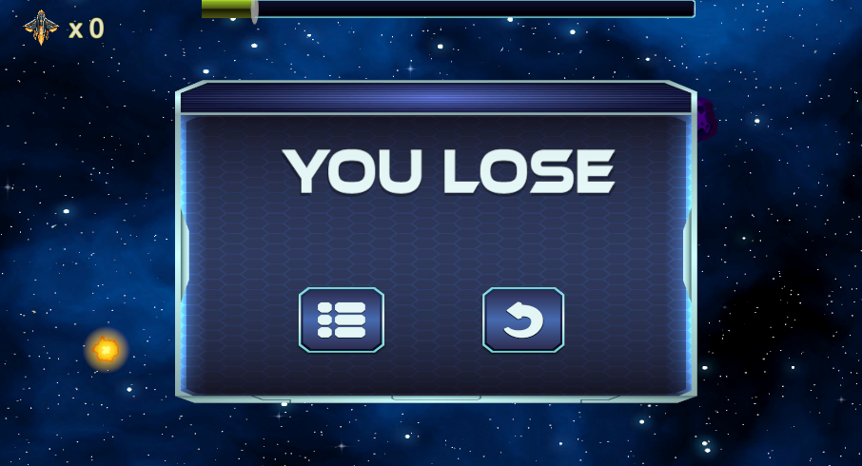

* Win scene

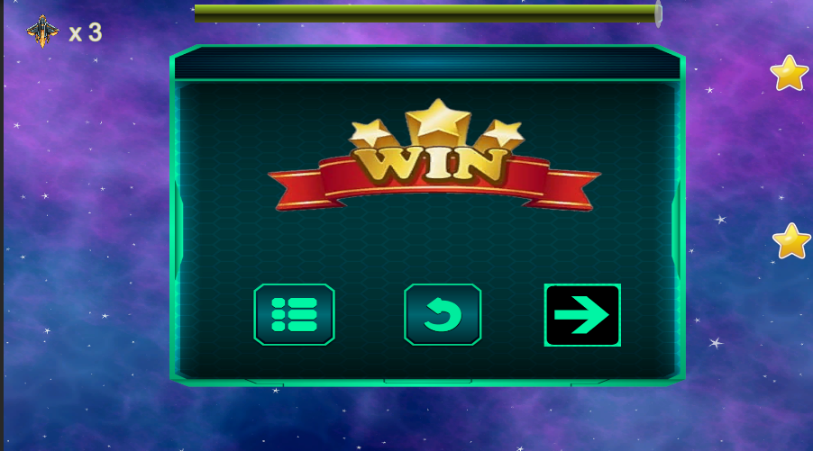

1. Gameplay:

Player move in four direction using WASD, and shoot using Left Click/Space bar. Asteroids spawn randomly, player lose health when get hit by asteroid and lose when HP drop to 0.

Play win when collect enough stars.